**How to upload OMR sheets**

* On ‘*Test ‘*Menu There is Submenus ‘*Upload OMR Sheet’* and ‘*Mapsubtopic*’.

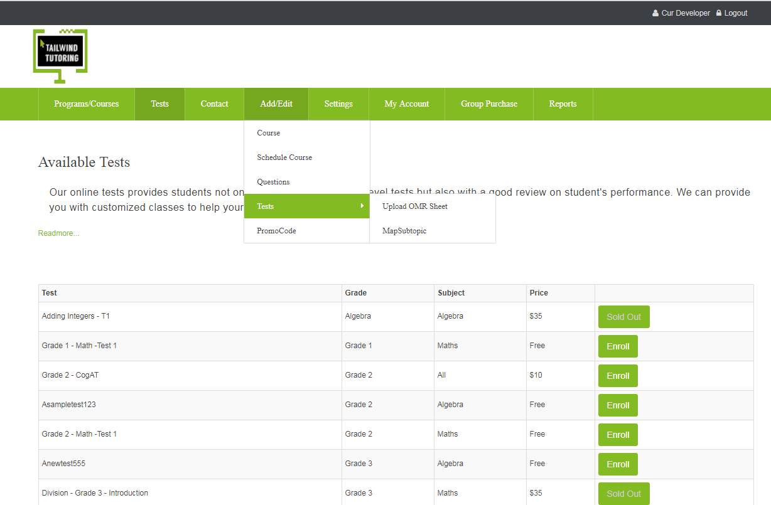

* Click ‘Upload OMR Sheet’ menu and there is a button for downloading OMR Application.

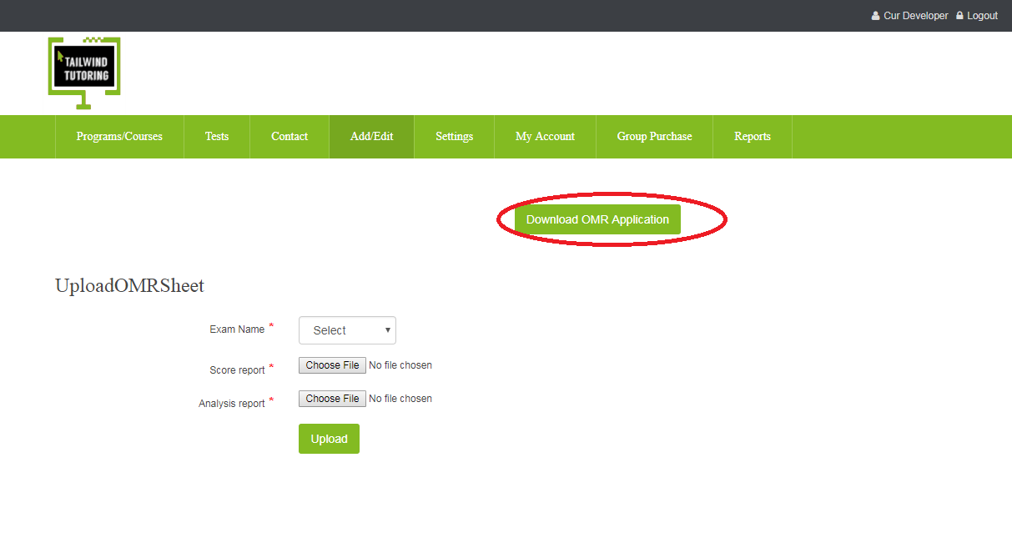

* Download and install the ‘AnyscancheckerOMR’ in your system .Activate the subscription using given productkey

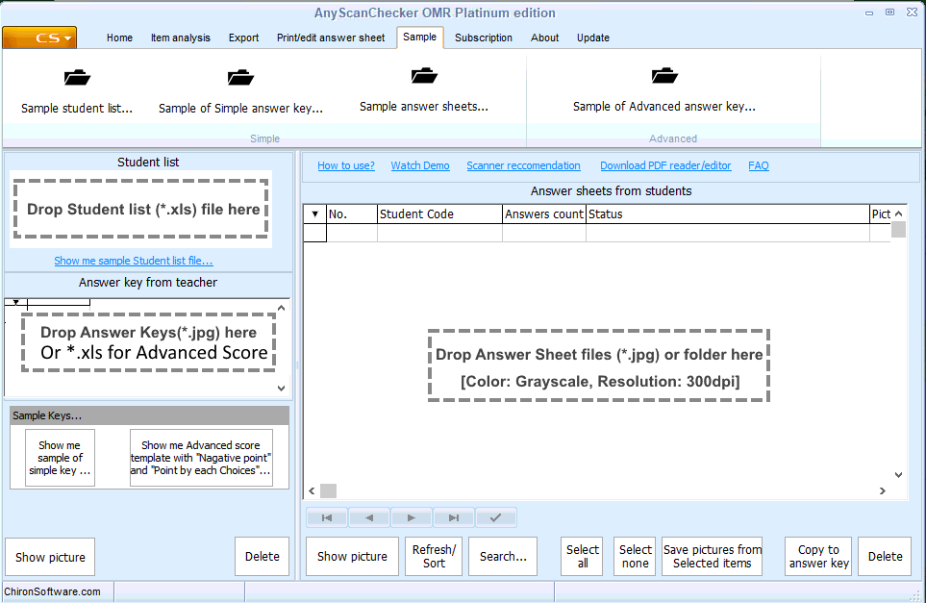

* Click on Home menu and then hit create job

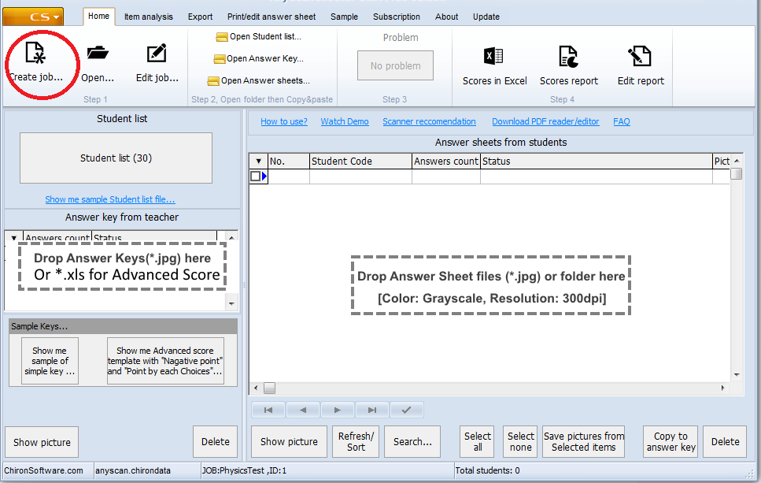

* Fill the mandatory fields Jobname,Subject name,Number of Questions,Score ,StudentCode digits

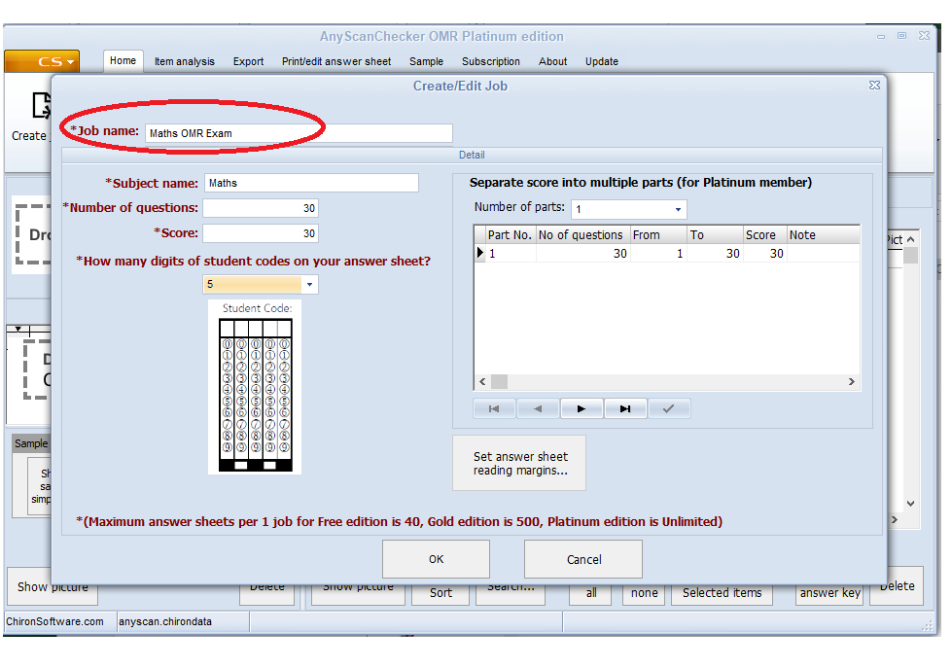

* Import the student list who took the OMR exams into ‘Anyscanchecker OMR’

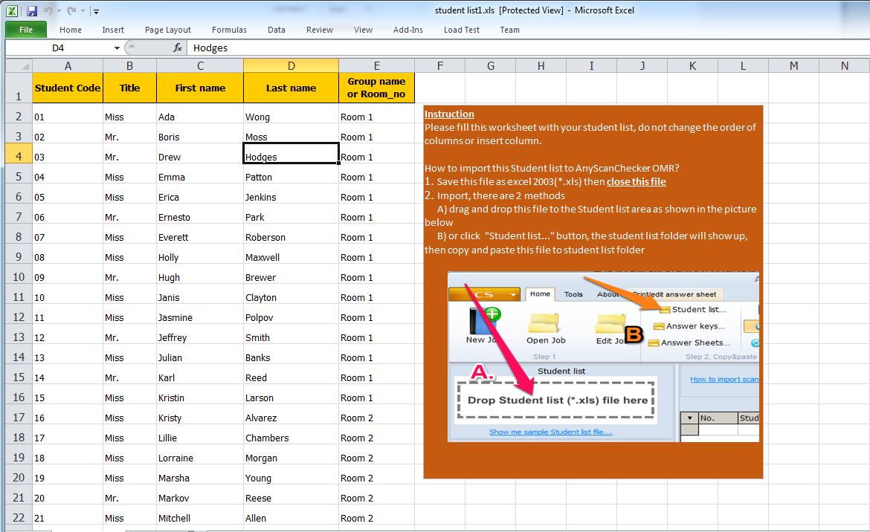

* You will get the sample student list worksheet and instructions from ‘Sample’ menu
* Fill the worksheet with your student list ,don’t change the column or insert the column.
* Save the file as excel ( .xls).

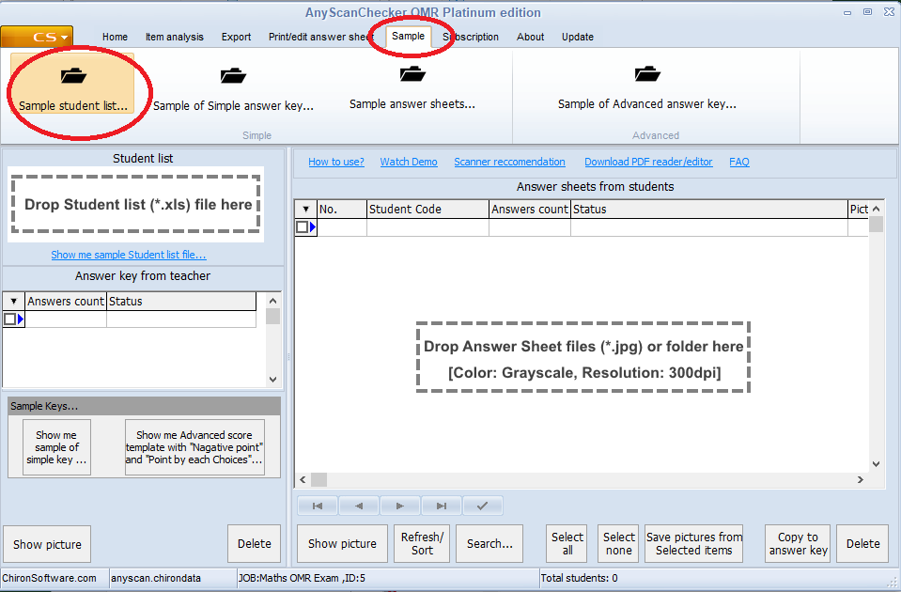

* Import the student list in two methods ,

a) Drag and drop the file to the student list area as shown in the picture below .

B) Click student list button, the student list folder will show up, then copy and paste this file to student list folder.

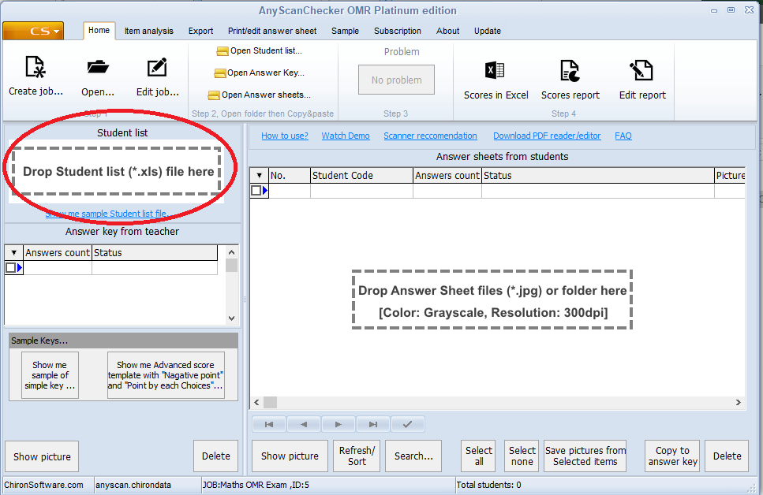

* Drag and drop the scanned OMR answer key image in to the ‘Answer key from teacher’ area

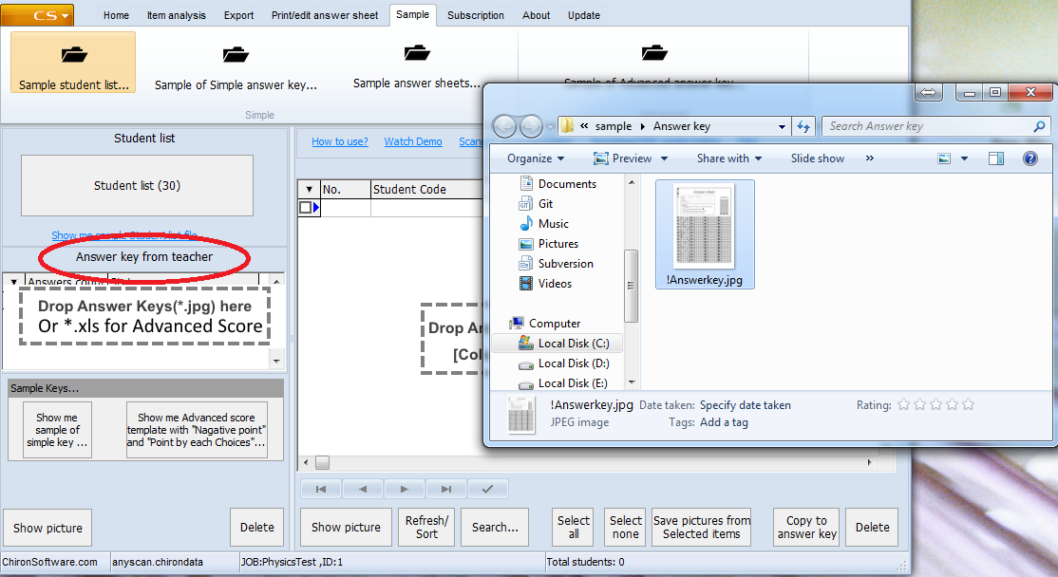

* Drag and drop scanner OMR answer sheets images into ‘Answer sheets from students ‘ area

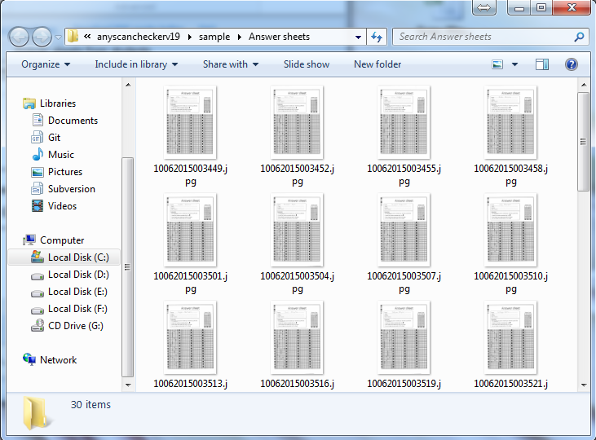

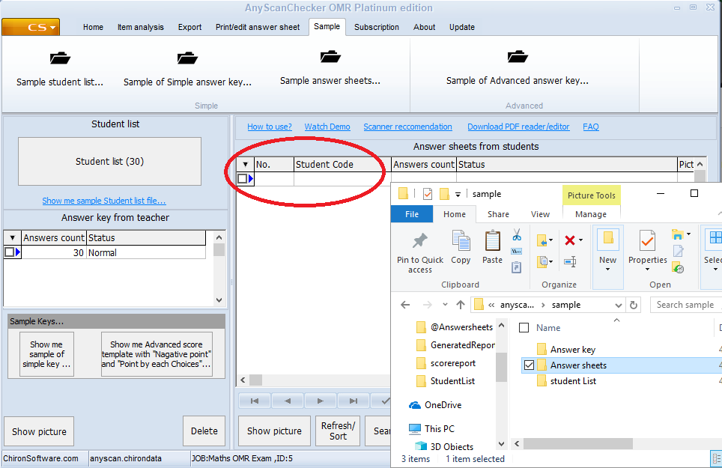

* After the importing all the files you will get the score reports and analysis report

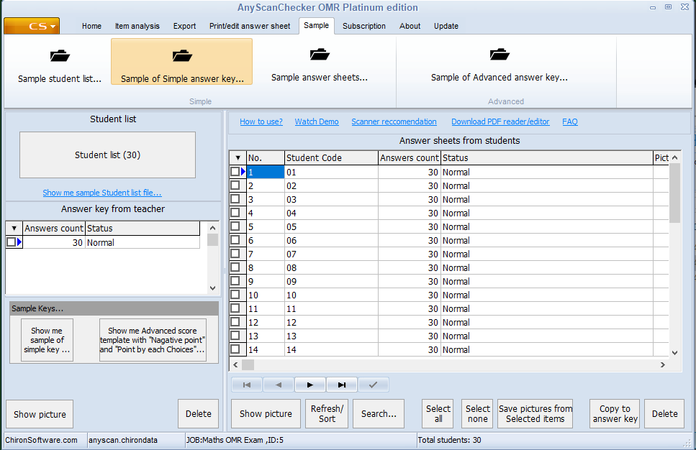

* Save the score report and analysis report in excel.

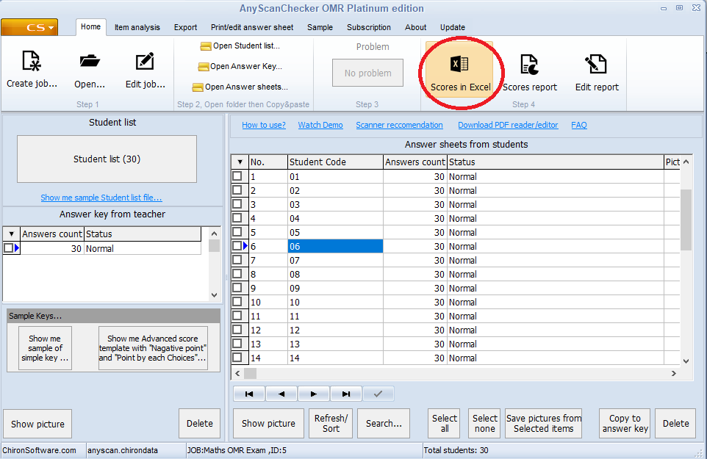

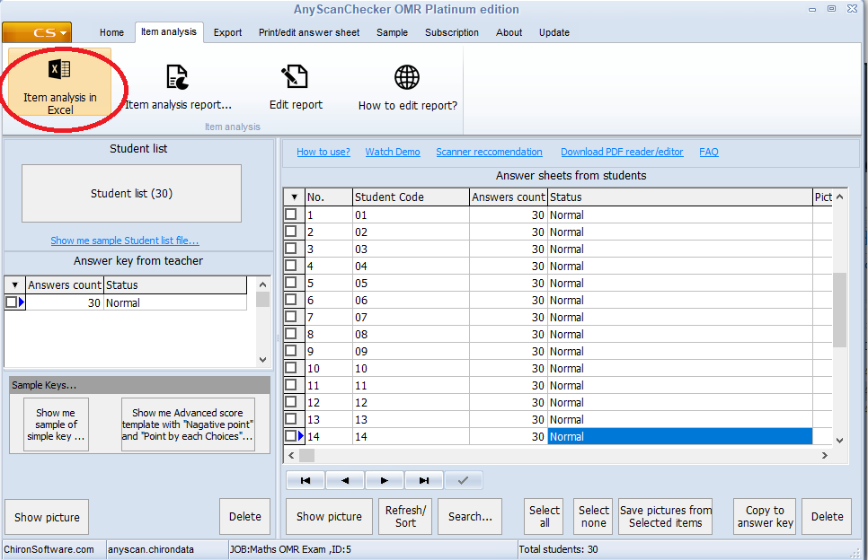

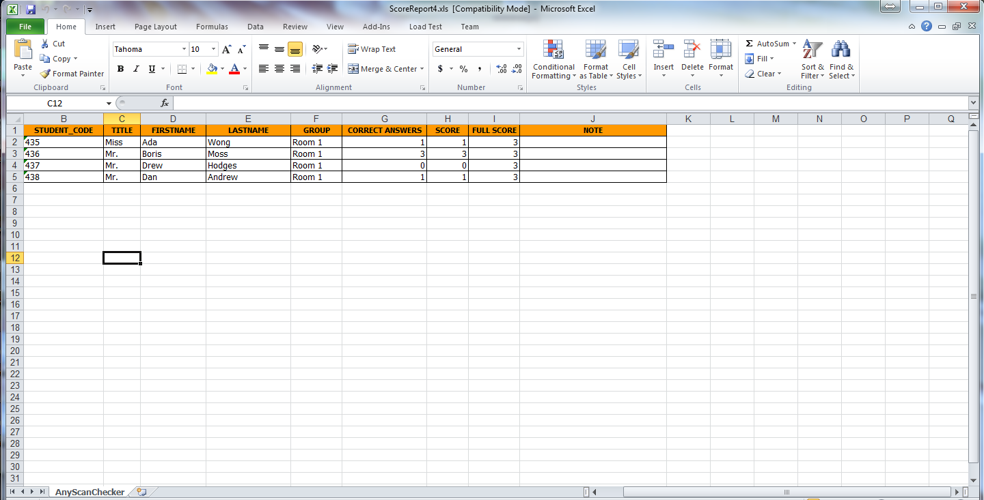

* Delete ‘item analysis, Frequency, Distribution’ sheets from worksheet and save the file.
* Don’t delete ’overview’ and’ full list’ sheets

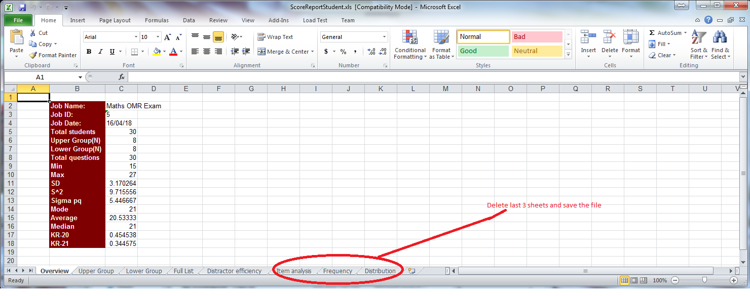

* Go to the home page click the Test menu .Create an exam category is OMR

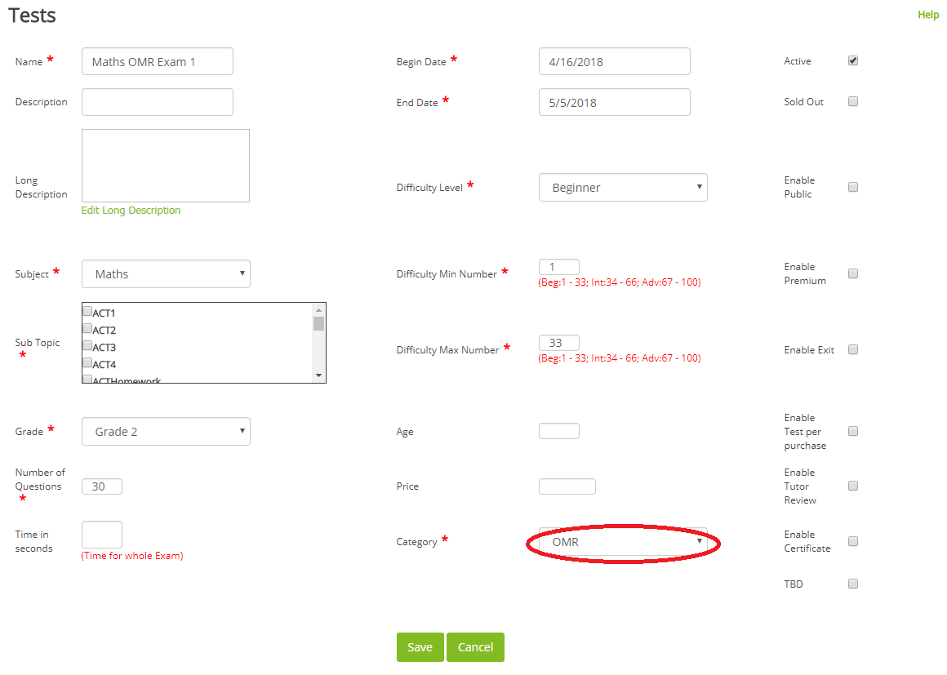

* When saving the exam you will redirect to a ‘Map Subtopic’ page

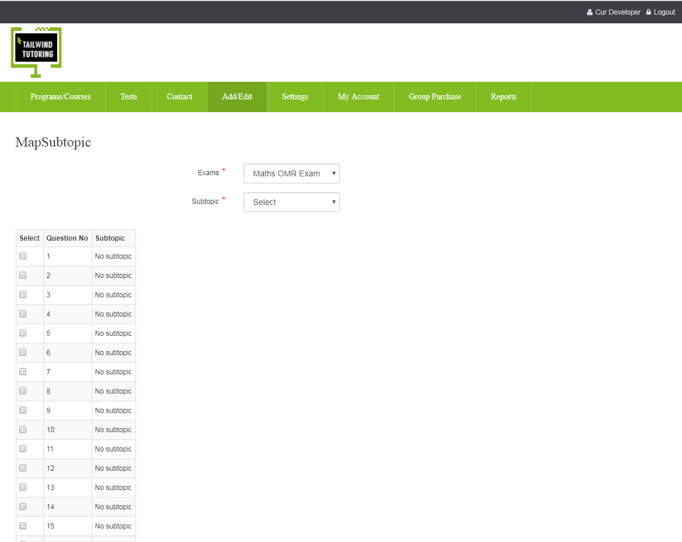

* You can map the subtopic with each question by selecting ‘Subtopic’ from drop down.

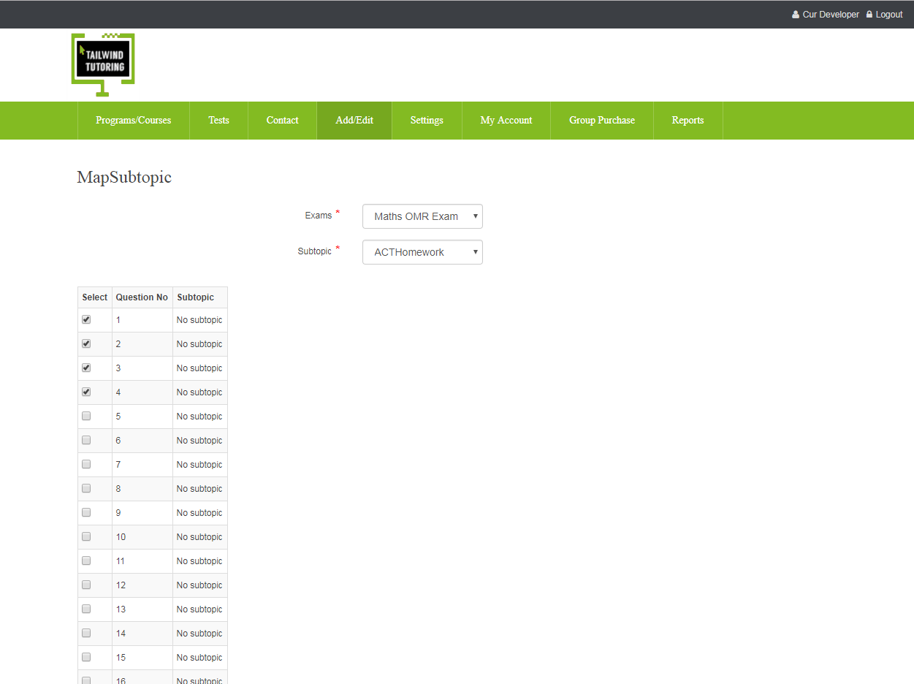

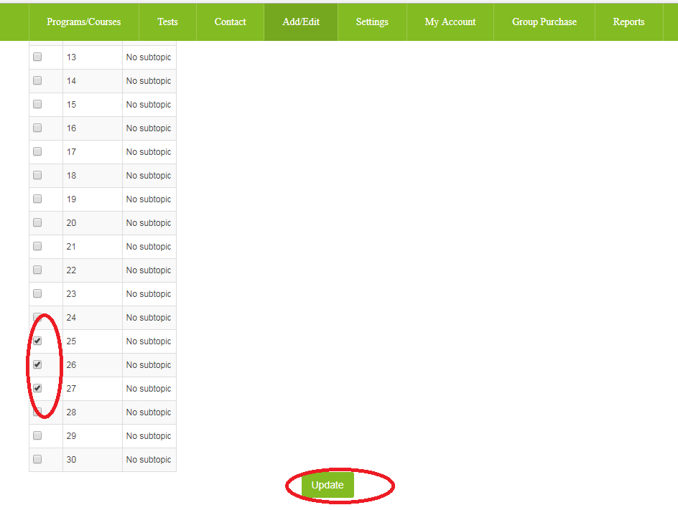

* Go to the Test Menu and hit ‘Upload OMR sheet’ submenu

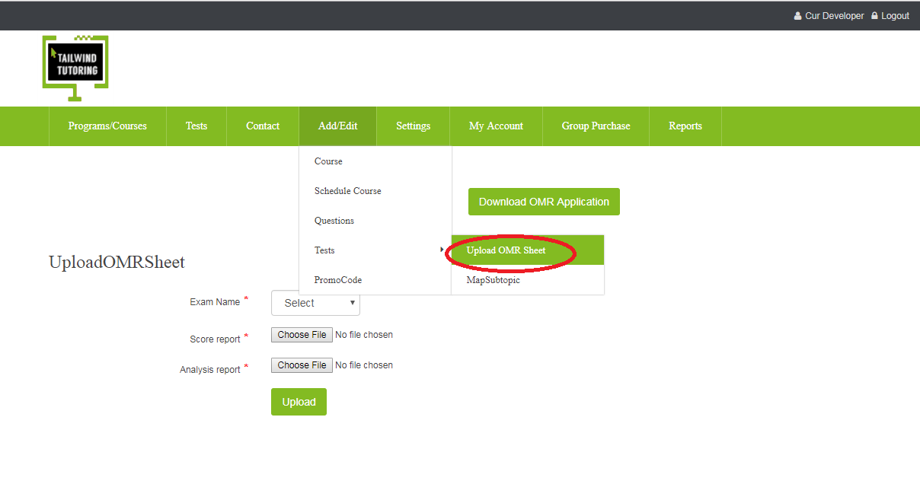

* Upload reports by selecting exams from the dropdown list.

